# Configuring Asus router to be ready for Microsoft Information Services to publish On the Spot website

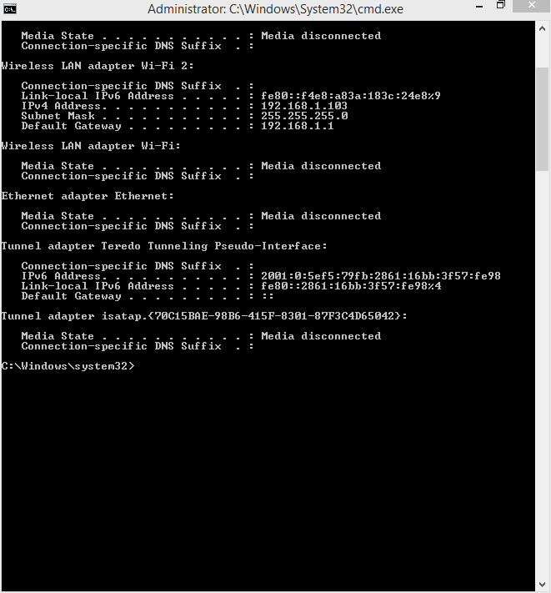

Figure - Finding local PC IP

Opening a Command Prompt Windows and typing in “ipconfig” reveals various information about the network that the computer is connected. The only important figure for this task is the Local IPv4 address assigned to the computer via the router on the network. In this case, the IPv4 address for this computer is 192.168.1.103.

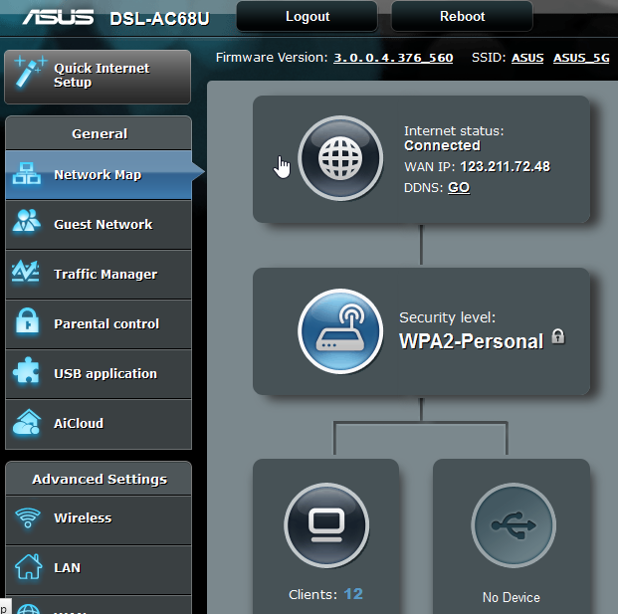

Figure - Assigned WAN IP

For Microsoft Internet Information Services to work as intended, and allow anyone with the IP of the website to access it, the WAN IP given by the router for the computer has to be known as well. There are several ways to achieve this, including searching Google for your IP. As access to the router was required for the next step anyway, it was also accessed to locate the WAN for the computer. While not strictly necessary for configuring Microsoft IIS, it should be noted that this router uses a function called a NAT forwarding table. It takes all packets going outbound and assigns one WAN IP for all computers on the network. The table keeps track of which incoming packets belong to which computer. This is done to reduce the number of IPs used by computers on the network as there is a finite amount that can be used. As illustrated, the WAN IP address of this computer is 123.211.72.48.

NOTE: This WAN IP is subject to change whenever the network automatically resets itself. Because of this, on the Team GitHub repository, will be an up to date file containing the latest WAN IP to access the website. If the site is ever inaccessible, please check this file for the latest IP as it may have changed unexpectedly.

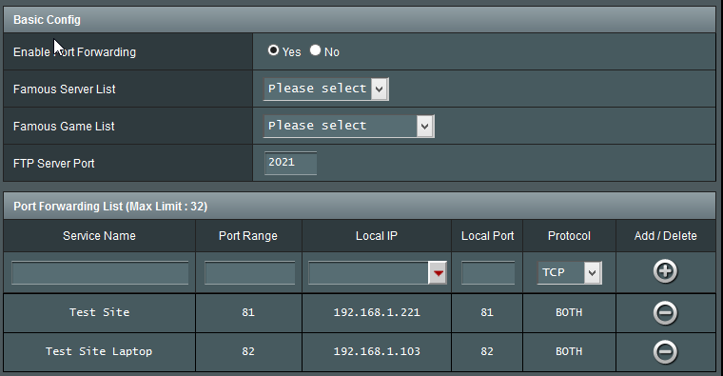

Figure – Port forwarding

Here the port forwarding function is utilised within the router. The default port for HTTP or HTTPS is 80 or 443 respectively. Port forwarding allows computers outside the local network to access the computers on the local network. Unfortunately another program on the computer also utilises this port and therefore IIS cannot utilise that port at the same time. The next available port for use was port 82; therefore port 82 was used for IIS.

Completing these steps now allows IIS to be configured.